***2nd Assignment***

1. Capture a 10 sec video footage using a camera of your choice. The footage should be taken with the camera in hand and you need to pan the camera slightly from left-right or right-left during the 10 sec duration. For all the images, operate at grayscale

a. Pick any image frame from the 10 sec video footage. Find the boundary of any object in the scene. You can pick regular shapes. You must show usage of Harris corner and Canny edge detection function.

We take the video from the camera and the identify a frame for which Harris Corner detection and canny edge detection are used to identify the corners and edges in the image.

The outputs are as follows

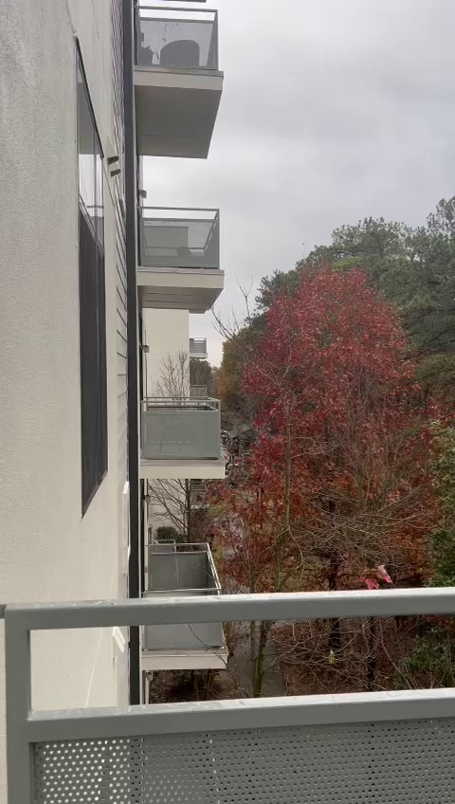

Original Image

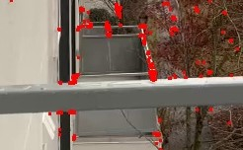

Harris corner detection

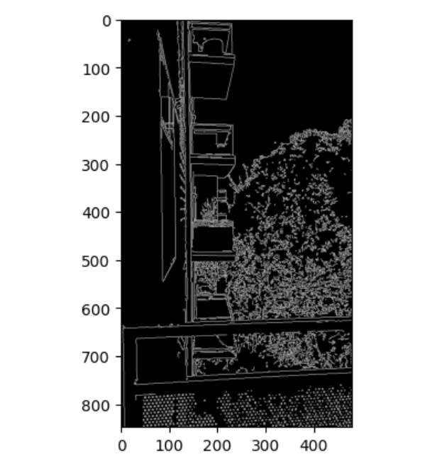

Canny Edge Detection

b. Pick another image frame from the set which also has the same object in view. Find all corresponding points of the object under consideration between these two images. Find the Homography matrix between the images

The Canny edge detection algorithm is composed of 5 steps:

* Noise reduction
* Gradient calculation
* Non-maximum suppression
* Double threshold
* Edge Tracking by Hysteresis.

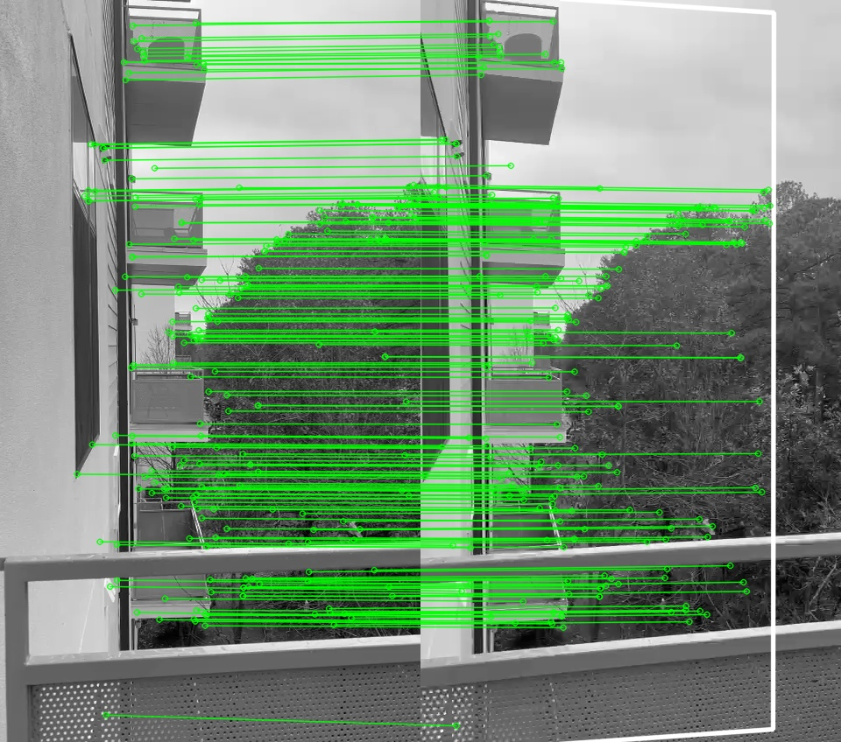

2. Implement the image stitching application in MATLAB (not necessary to be real-time). Test your application for any FIVE of a set of 3 image-set available in the gsu_building_database. That is, your stitching application should stitch 3 images. You must test the performance of your application

for FIVE such sets.

 

Image1 Image 2



Image 3

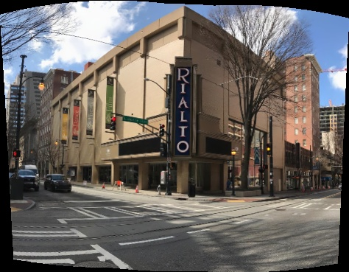

Panaromic Output from MatLab

3.Implement an application that will compute and display the INTEGRAL image feed along with the stereo and RGB feed. You cannot use a built-in function such as “output = integral_image(input)”

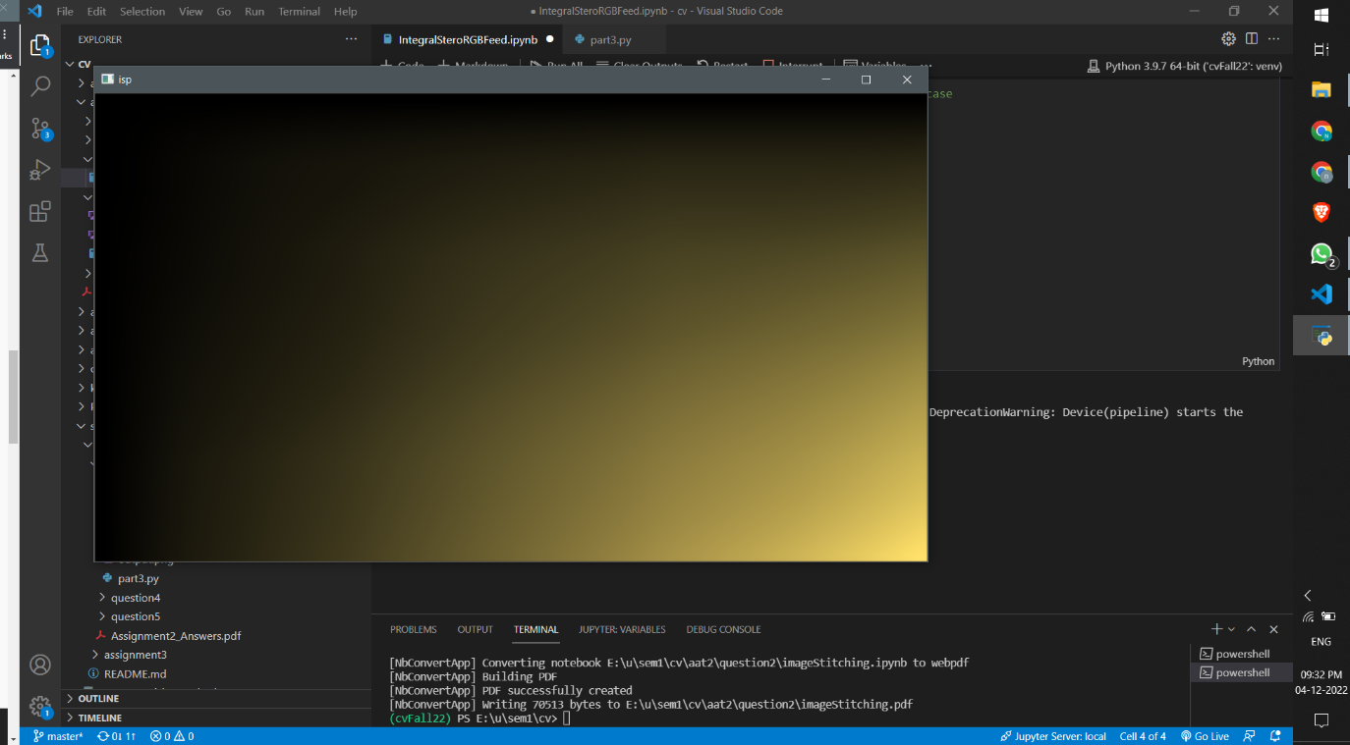

Output

4.Implement the image stitching, for at least 1 pair of images. Use SIFT features. If using Depth AI API this should function in real-time. You can use built-in libraries/tools provided by the DepthAI API. If available, you can also simply call any built-in function “image_stitch(image1, image1)”. However, in that case, you need to show a 180 or 360degree panoramic output.

SIFT is quite an involved algorithm. There are mainly four steps involved in the SIFT algorithm. We will see them one-by-one.

* Scale-space peak selection: Potential location for finding features.
* Keypoint Localization: Accurately locating the feature keypoints.
* Orientation Assignment: Assigning orientation to keypoints.
* Keypoint descriptor: Describing the keypoints as a high dimensional vector.
* Keypoint Matching

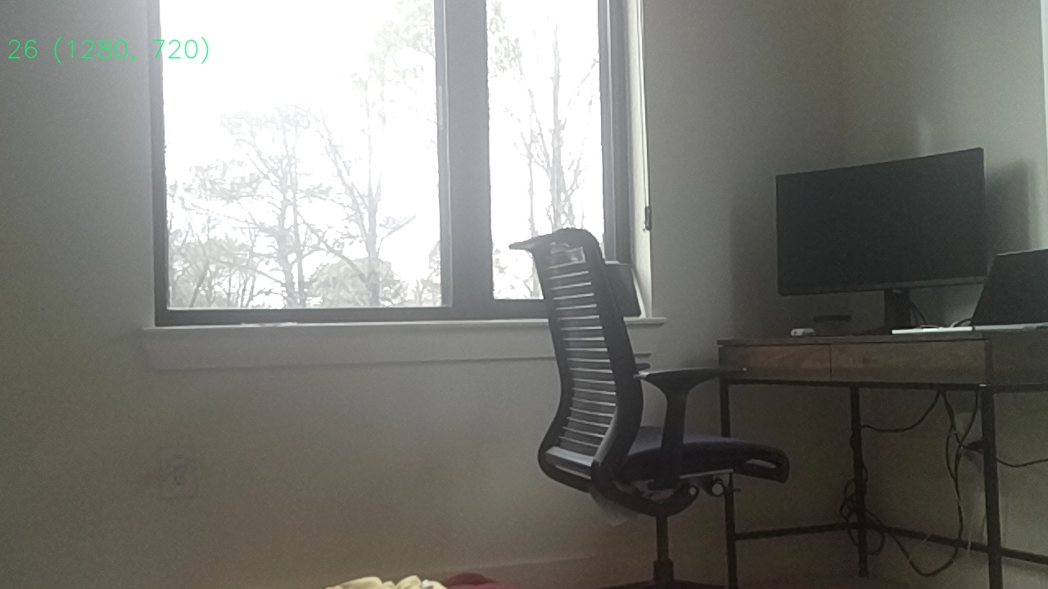

Image 1

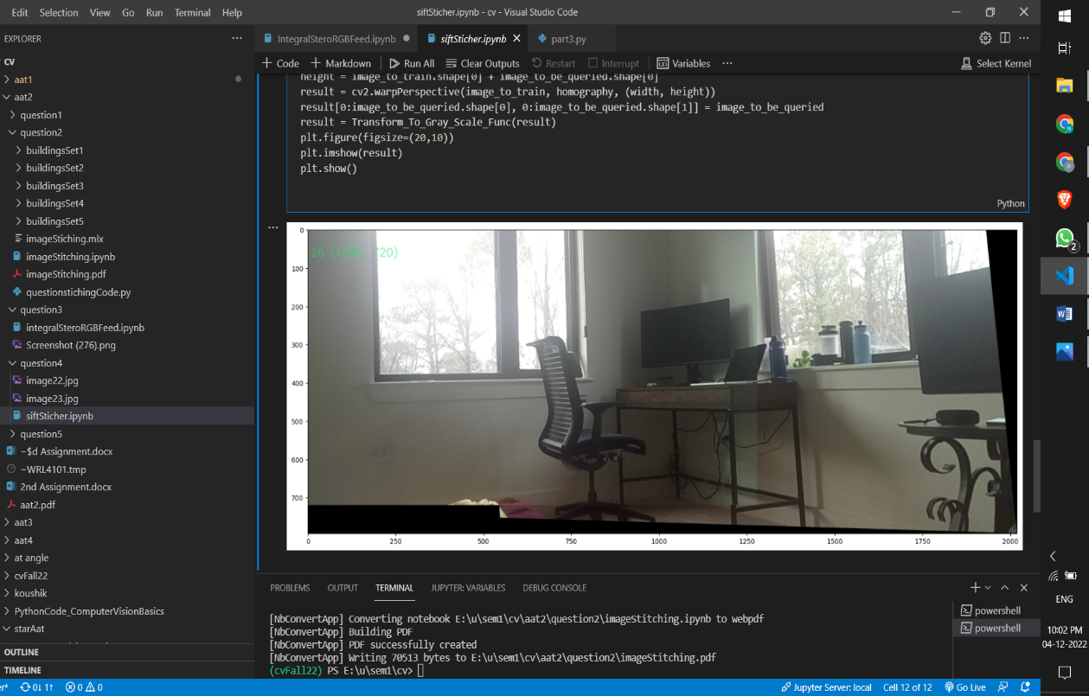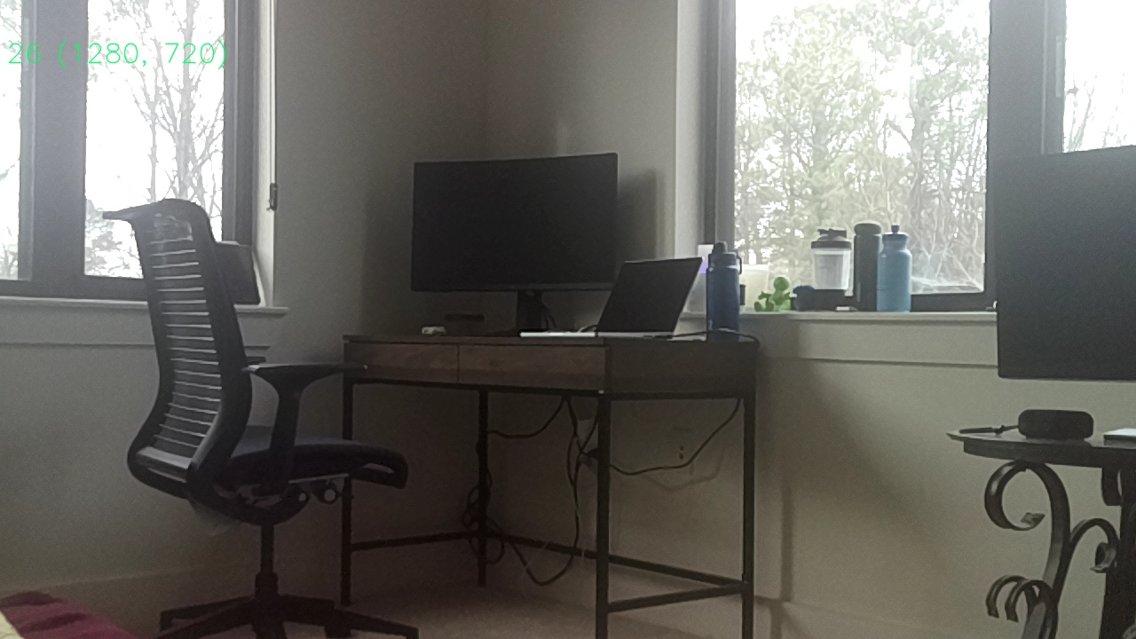Image 2

Output

5. Repeat (4) using ORB features. You can make assumptions as necessary, however, justify them in your answers/description.

The Full form off ORB is Oriented Fast and Rotated BRIEF. ORB performs as well as SIFT on the task of feature detection (and is better than SURF) while being almost two orders of magnitude faster. ORB builds on the well-known FAST keypoint detector and the BRIEF descriptor. Both of these techniques are attractive because of their good performance and low cost. 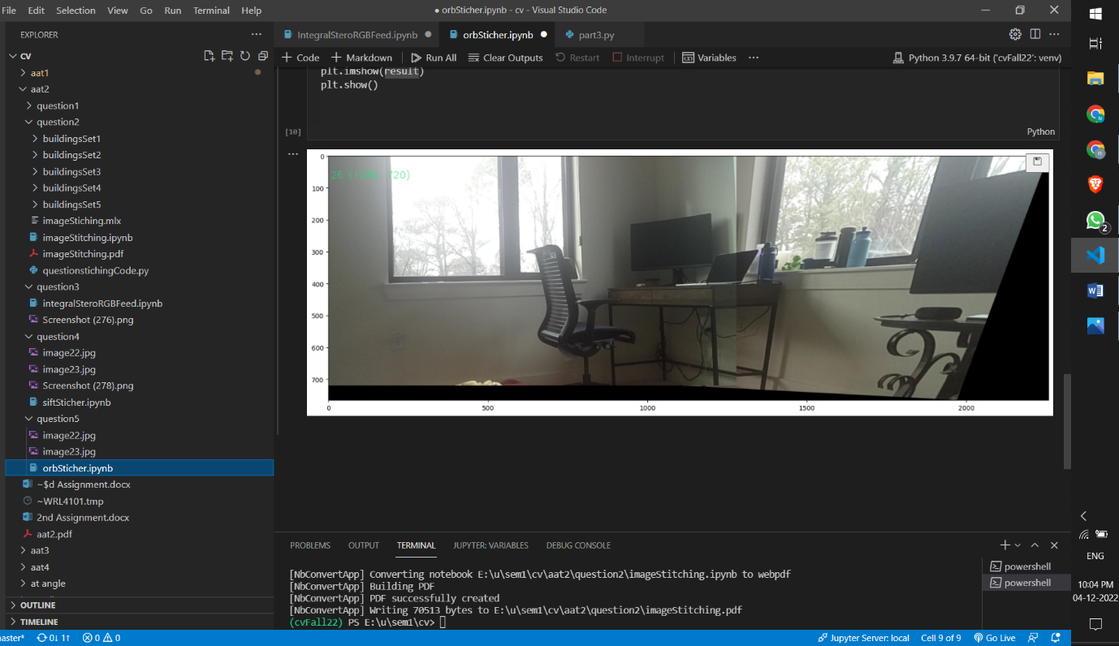

Output

Recording link for this assignment

https://drive.google.com/file/d/11260RUhCjsV3DXEOmRt-pmJ8eeLnjGwL/view?usp=sharing